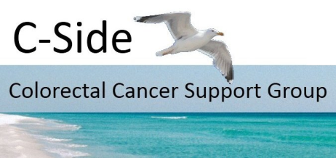
Gift Aid No: EW02008
http://www.c-sidebrighton.org

ANNUAL REPORT 2014 – 2015

We have had a really good year with a number of new and potential members and a regular attendance at meetings and social events. We endeavoured to maintain a balance of guest speakers, social and other activities, they are summarised below:-
- Talks and Discussions
  - Ruth - A talk about Odyssey an organisation which uses the stimulation of surprise and the outdoors to combat the psychological and emotional devastation caused by illness.
  - Report on the new Macmillan Horizon information & support centre, due to open in the Autumn of this year.
  - Mark Danieletto - palliative care. Mark gave a illuminating description of his role in his new job and how recognising how the uniqueness of the individual is pivotal to his work.
  - Sarah & Grace – brought the group up to date with the more systematic approach to post-treatment follow-up, that is now in place.
  - Pauline & Mike – Described developments in pharmacist training and their involvement with the Sussex MPharm Patient Public Consultation.
- Activities
  - Beating Bowel Cancer Patient Day, with bus hire. This was the third consecutive annual trip.
  - WiFi training at Saltdean Tavern, a primer on using wifi hotspots for web & email access.
  - Jazz Night at St Wulfran’s Church, Ovingdean, a brilliant night’s entertainment and profitable too; the event raised an astonishing £590 for C-Side’s benefit.
  - Picnic in the gardens of St. Margaret’s Cottage.
  - Walk at Cuckmere Haven, terminating with lunch at the Cuckmere Inn.
  - An information stand at the BSUH Cancer Centre.
  - Xmas lunch at Saltdean Tavern.

C-Side was also represented at various forums: NHS England’s S.E. Coast Cancer Strategic Clinical Network meeting in Crawley; Support Group Network meeting at the Olive Tree in Crawley; Sussex Partnership Group meetings in Brighton and two other bowel cancer support groups: Colonaid in Worthing and the new Mid-Sussex Support Group in Haywards Heath.
When we have events and meetings off-site it is important that the cost to the individual should not be a barrier to attendance. For this reason these events are often subsidised, with the opportunity for members to make a contribution should they choose to. Our treasurers report shows that we are financially comfortable mainly because of the individual generosity of members and holding an annual fund-raising event. We won’t be able to repeat the roaring success of this year’s Jazz Night, but we’re open to suggestions for alternatives.
The C-Side website continues to attract interest from a wide variety of visitors; our depleted stock of brochures will soon be replenished with one in a fresh design. Several members are not able to attend meetings either because they are in full-time employment or, sadly, because they are not well enough. We stay in touch with them by ensuring that they receive news and reports of our meetings.
As might be expected, several member of C-Side had a few ups and downs with their health during the year; none more so than Denise who having just got over one major problem in the Spring encountered another in December. Denise is so central to what we do, we’re pleased that she is recovering well. Indeed we hope that C-Side’s determination to help and support all of our members will contribute to their ensuring a healthy and happy year ahead.

